**1 a)** Complete the word equation for aerobic respiration.

glucose + oxygen = ……… + ….…… (2)

**b)** Which organelles in a cell are used to carry out aerobic respiration? (1)

**c)** Energy is released from the glucose? What sort of chemical reactions release energy? (1)

**d)** Name two metabolic processes in animals that require the energy from respiration. (2)

**e)** Much of the energy released from respiration is wasted. In what form is this energy? (1)

**f)** Why is this waste product useful to mammals? (1)

**2** Are the following statements true or false?

**a)** Anaerobic respiration only takes place in animals

**b)** Aerobic respiration releases more energy than anaerobic respiration.

**c)** Yeast are microbes that respire anaerobically to produce lactic acid.

**d)** Only plants carry out photosynthesis and only animals carry out respiration.

**e)** Lactic acid can be converted back into glucose in the liver. (5)

**3** Plants make all the chemicals they require through photosynthesis. To speed up photosynthesis, plants need a suitable temperature, carbon dioxide and light.

**a)** Where does photosynthesis take place in a plant cell? (1)

The graph below shows how the rate of photosynthesis changes with increasing light intensity.

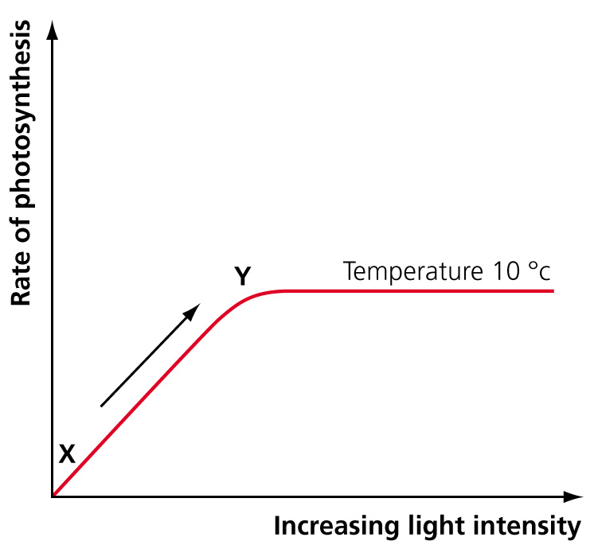

**b)** What is limiting the rate of photosynthesis between points X and Y on the graph? (1)

**c)** Explain your answer. (3)

**d)** On the graph, draw a line to show how the rate of photosynthesis changes if the temperature is raised to 20°C. (2)

**e)** What other factor may be limiting the rate of photosynthesis now? (1)

**f)** Farmers and growers need to maximise the yield of their crop.

**i)** What is meant by yield? (1)

**ii)** Why is yield important to farmers? (2)

**g)** Describe one way in which a farmer could reduce the effect of a named limiting factor. (2)

**4** Use the words below to complete the following passage.

Metabolic reactions are catalysed by ……… in the cells. Some metabolic reactions break down large ……… into smaller ones. Proteins cannot be stored in the body. Proteins are broken down into ……… acids which are further broken down into urea in the ……… . The ……… filters urea from the blood.

Some metabolic reactions build up molecules. In plants the process of ……… creates glucose and this is built up into .……… for storage and cellulose for ……… walls. In animals, glucose is converted into ……… and stored in the liver. (8)

**enzymes photosynthesis   cell   amino kidney   molecules   starch   glycogen   liver**

**5** Yeast is a microbe that can be grown under anaerobic conditions in a fermenter. The graph shows how the glucose and ethanol concentrations changed in the fermenter over a 24-hour period.

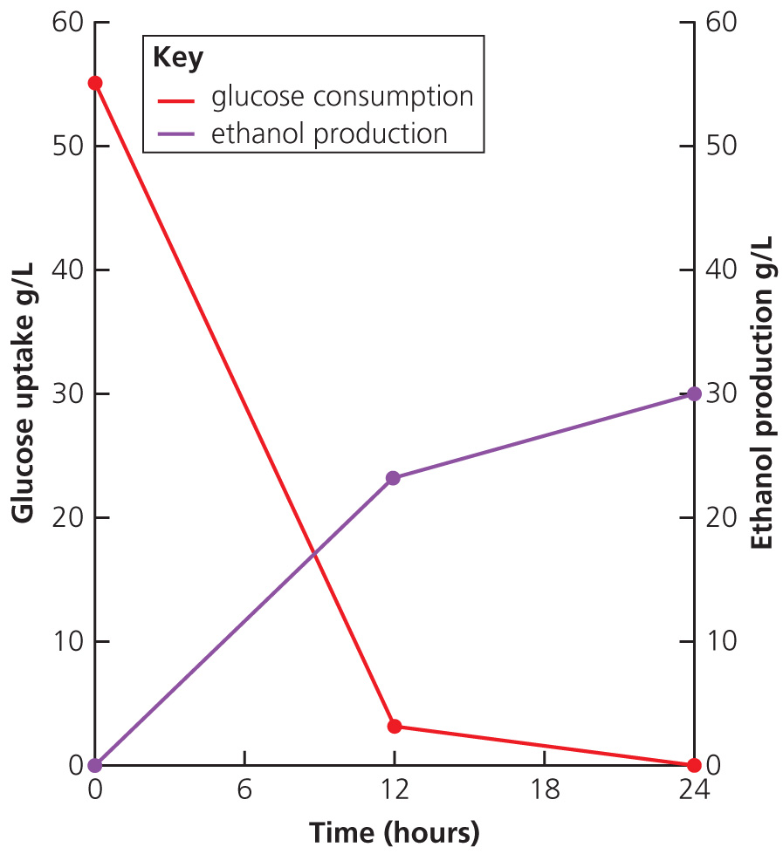

**a)** What does anaerobic mean? (1)

**b)** What is fermentation? (2)

**c)** Write a word equation to show the process of fermentation carried out by the yeast. (3)

**d)** At what time are the levels of glucose equal to the levels of ethanol? (1)

**e)** Explain why the level of ethanol goes up as the glucose levels drop. (3)

**6** **a)** Complete the table below to show the differences between aerobic and anaerobic respiration in humans.

|  |  |  |
| --- | --- | --- |
|  | Aerobic | Anaerobic |
| Reactants |  | Glucose only |
| Products | Carbon dioxide + water |  |
| % Energy released | 100 |  |

(4)

**b)** Explain what is meant by an oxygen debt. (2)

TOTAL = 50

**1** **a)** carbon dioxide; water (2)

**b)** mitochondria (1)

**c)** exothermic (1)

**d)** movement, growth, reproduction, cell division (1 mark each = 2)

**e)** heat (1)

**f)** Helps to keep body temperature at a constant high level. (1)

**2 a)** False

**b)** True

**c)** False

**d)** False

**e)** True (5)

**3 a)** chloroplasts (1)

**b)** light intensity (1)

**c)** As the light intensity increases, the rate of photosynthesis increases; all other variable are constant; after Y light no longer affects the rate. (3)

**d)** Line should follow line of X to Y but then get higher; line plateaus later. (2)

**e)** carbon dioxide concentration (accept water levels) (1)

**f)** **i)** Yield is the useful part of a crop. (1)

**ii)** A high yield means that a farmer has more to sell; farmers grow crops to produce a useful product that can help them earn money. (2)

**g)** Temperature: put paraffin burners inside a greenhouse or polytunnels; carbon dioxide: paraffin burners release carbon dioxide; light intensity: increase the artificial lighting in fields, greenhouses or polytunnels. (1 mark for named factor + 1 for how controlled = 2)

**4** Metabolic reactions are catalysed by **enzymes** in the cells. Some metabolic reactions break down large **molecules** into smaller ones. Proteins cannot be stored in the body. Proteins are broken down into **amino** acids which are further broken down into urea in the **liver.** The **kidney** filters urea from the blood.

Some metabolic reactions build up molecules. In plants the process of **photosynthesis** creates glucose and this is built up into **starch** for storage and cellulose for **cell** walls. In animals, glucose is converted into **glycogen** and stored in the liver. (8)

**5** **a)** without oxygen (1)

**b)** Anaerobic respiration that takes place in yeast (microbes). (2)

**c)** glucose → carbon dioxide + ethanol (3)

**d)** 9 hours (1)

**e)** Glucose is absorbed by the yeast; yeast use up the glucose for anaerobic respiration; as respiration rate increases, more glucose is used and the levels of ethanol increase. (3)

**6** **a)**

|  |  |  |
| --- | --- | --- |
|  | Aerobic | Anaerobic |
| Reactants | **Glucose and oxygen** | Glucose only |
| Products | Carbon dioxide + water | **Lactic acid** |
| % Energy released | 100 | **5** |

(4)

**b)** After extreme exercise, a person continues to breathe deeply; this is to replenish the oxygen used up in the exercise; the oxygen is used to break down the lactic acid. (2)

TOTAL = 50